Steven Sousa

Prof. David Breski

CSC150

November 23rd, 2020

Capstone Design Documents

Functional Design: The Enigma Machine will encrypt or decrypt messages.

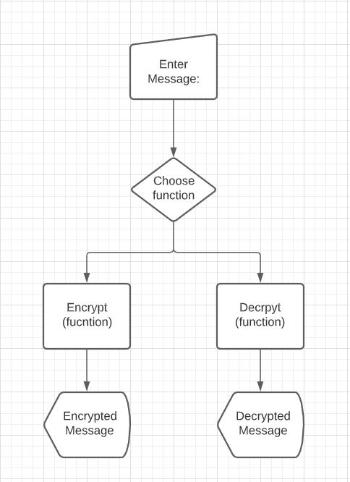Detail Design:

Algorithm description: The Enigma machine has 3 rotors (large, medium, and small), where an inputted letter goes through each rotos (changing the letter as it moves to the next rotor) and finally hits the “reflector” where the letter goes through all the rotors again but backwards. Each time a letter goes through the first rotor, that rotor clicks. Once the first rotor clicks 26 times, the middle rotor will click once, and so on until the small rotor clicks 26 times and the encryption process repeats itself. This allows for more than 17000 different combinations. Between the input and the first rotor is the plugboard, which would swap the inputted letter according to the plugged letter. Ex: if ‘a’ is connected to ‘z’ on the plugboard, once the user types ‘a’, the plugboard would swap that letter to a ‘z’ and then it would send ‘z’ into the rotor mechanism.

UI Design:

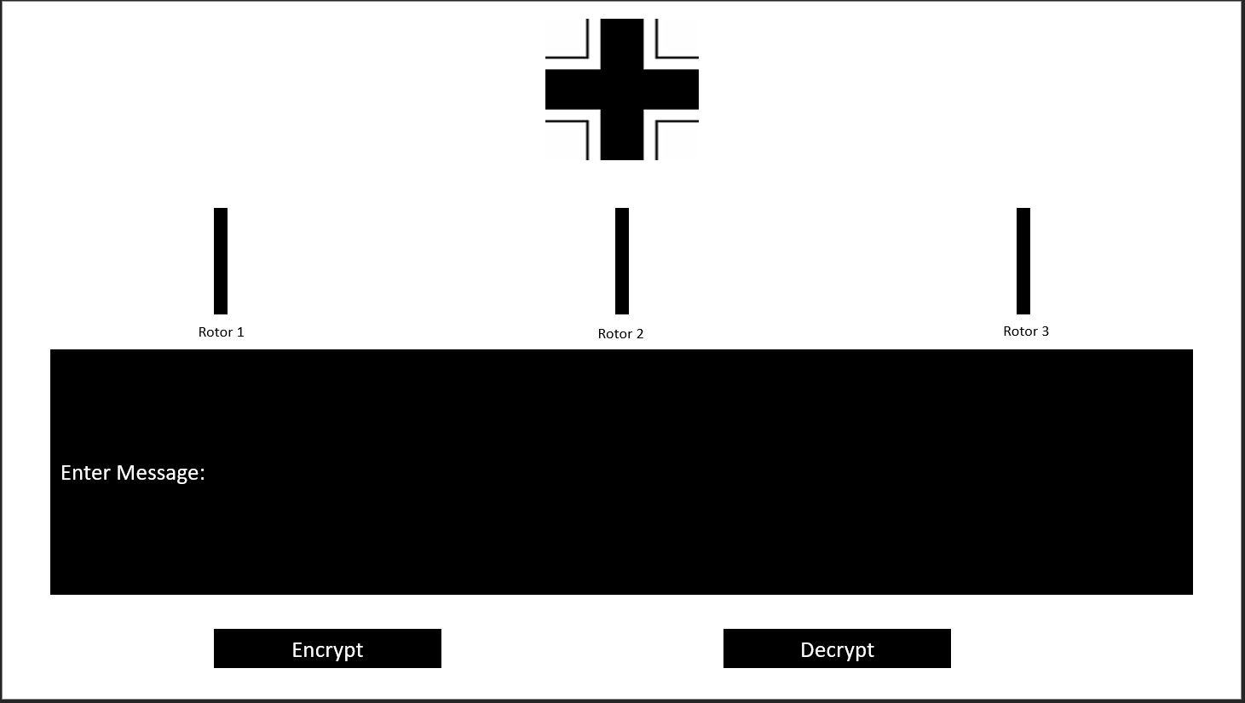

3rd Party References: It may be necessary to use install the py-enigma 0.1 library by using pip install py-enigma command. If not, I will let you know by submitting with the program a ReadMe.txt file with all the instructions necessary to run the code.